1.Showed the background color as green for Portrait layout & the Log information is displayed in Log Cat (Run)which shows Log of my name & user.

2.Showed Build successfull in Gradle console Window

.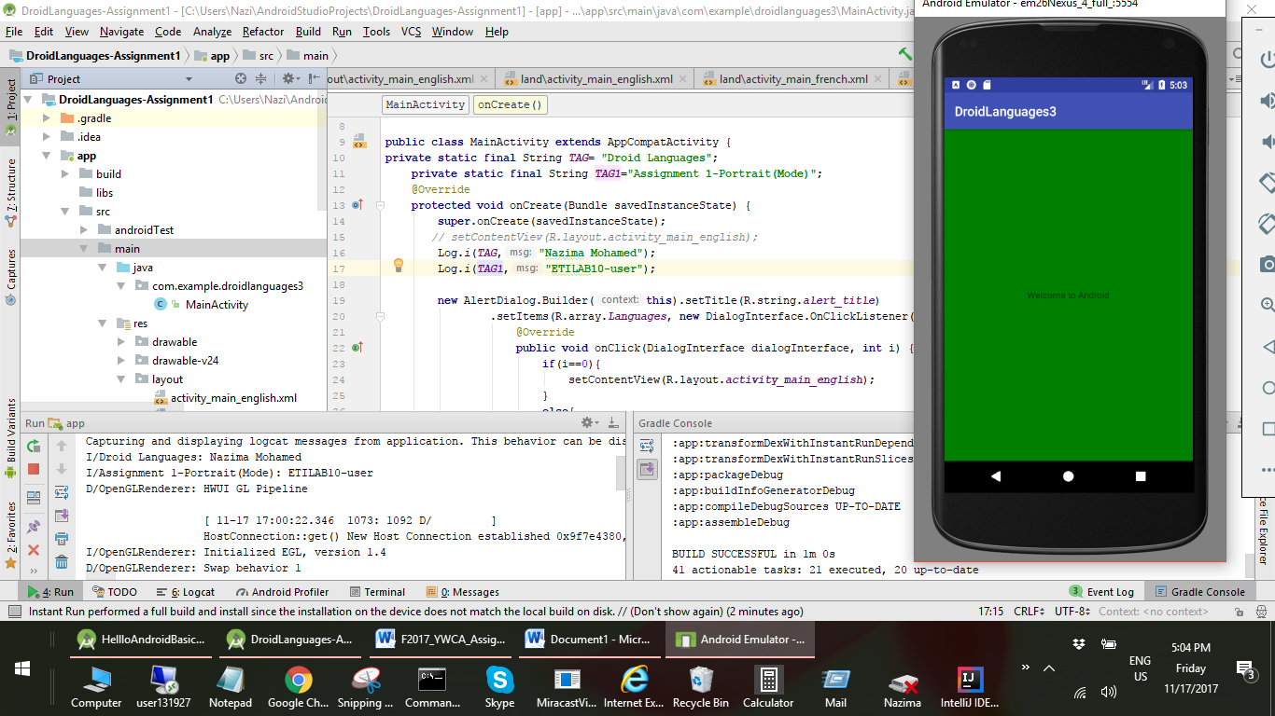

2.Showed the app while running on Landscape layout-done by rotating the orientation in the emulator.

3.Shows the CPU cycles & memory usage of Droid Languages app by selection of Android Profiler.

4.Added two different items in array(German, Latin) which refers the string value resource qualifier & created layout for those two activities.

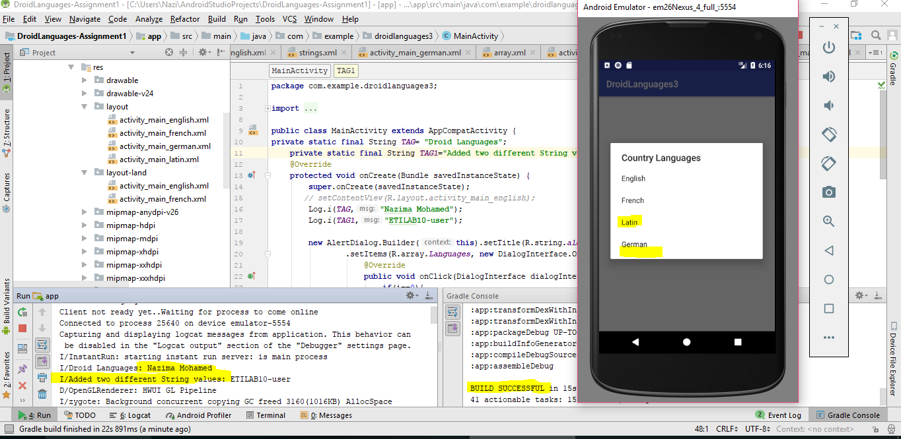

5.Added strings are displayed in Landscape layout.

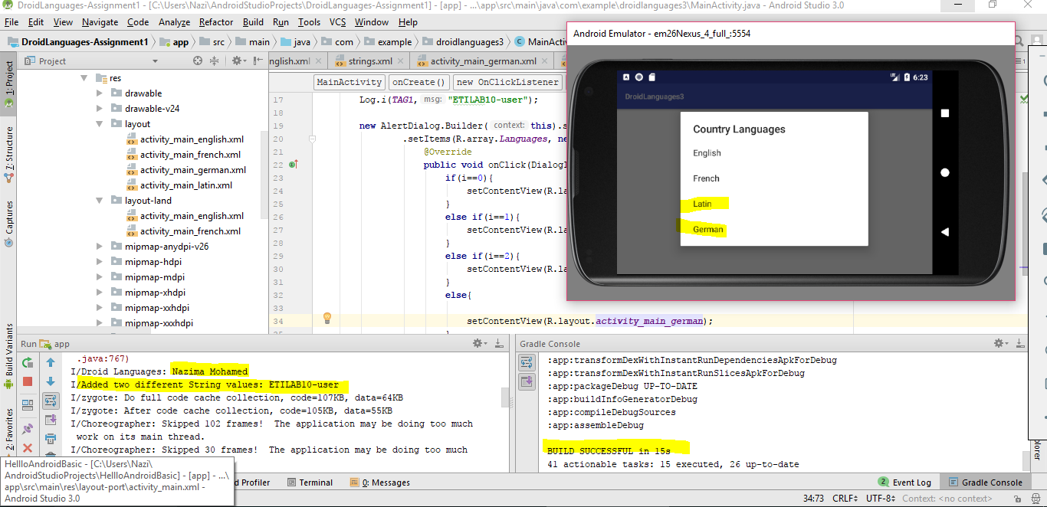

6.Showed LOGCAT information of my project.

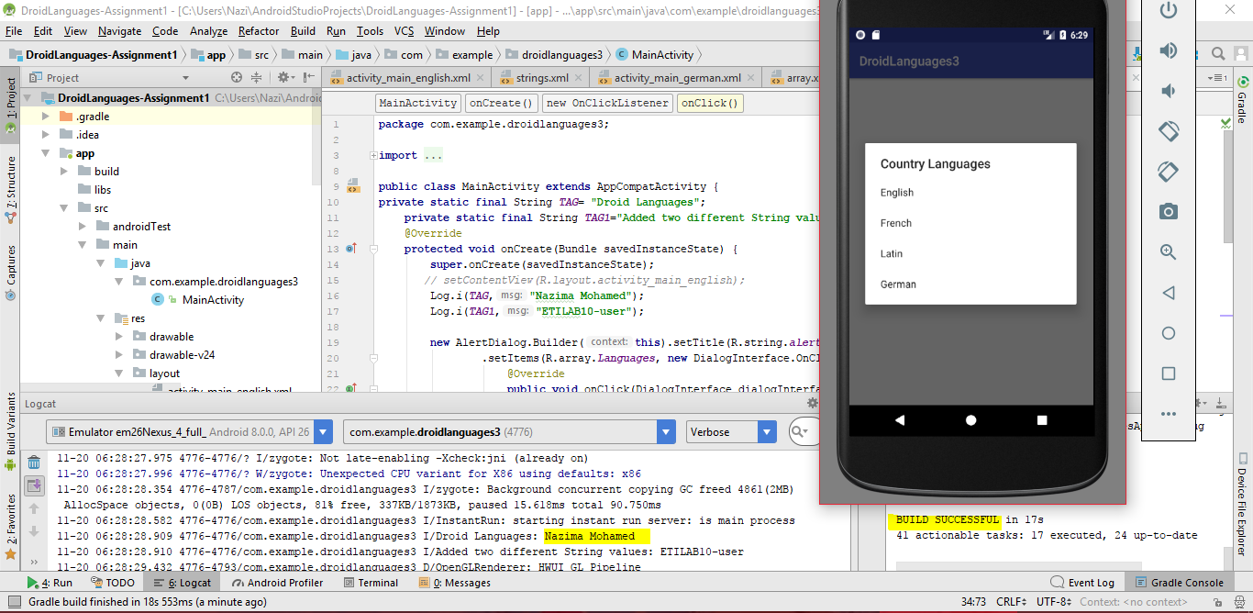

7.Showed the LogCat information for the Activity Manager filter

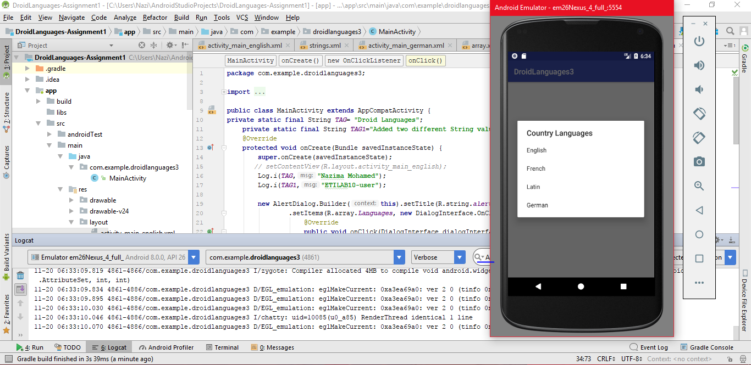

8.Showed LogCat information for Android Runtime filter.

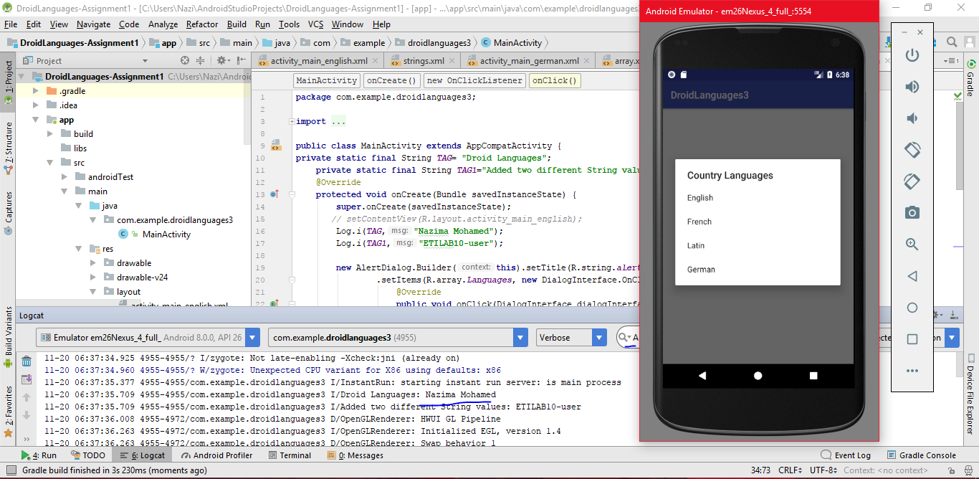

II.Grades Calculator

Showed the LogCat information & Build successful in the Grades Calculator. And represent TextViews are Left Justified & editText are right justified.

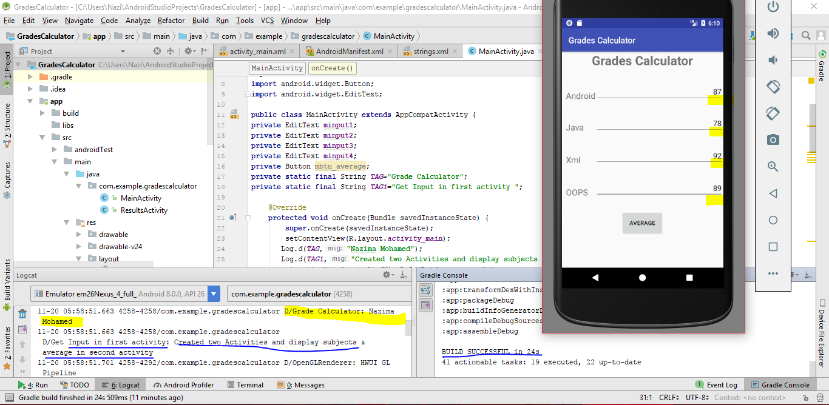

2. All inputs taken from the user is in Integer.

Showed that Average button is provided with appropriate padding & margins. 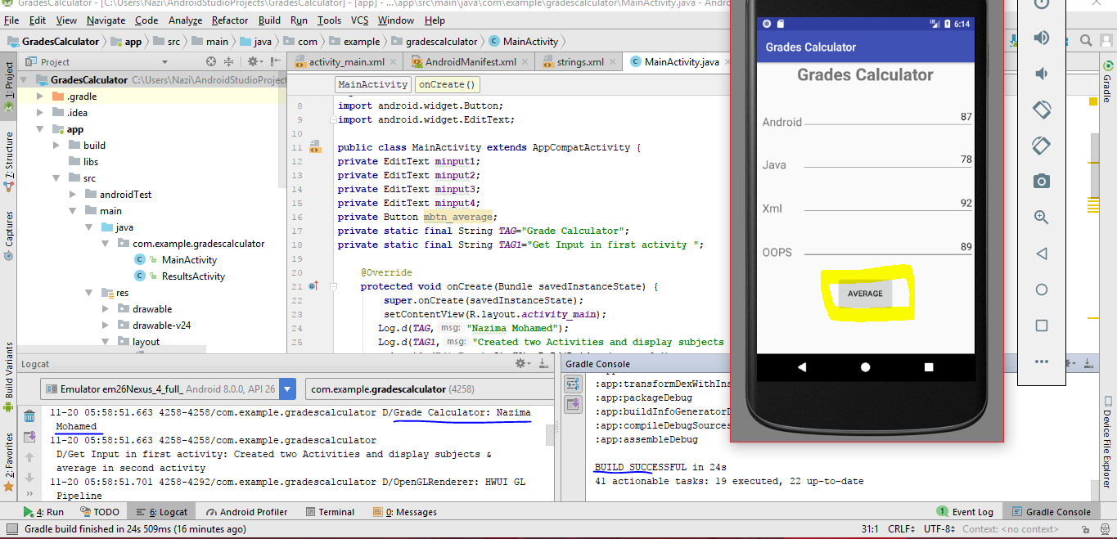

3.Showed the details of all subjects & displayed the average of all Grades

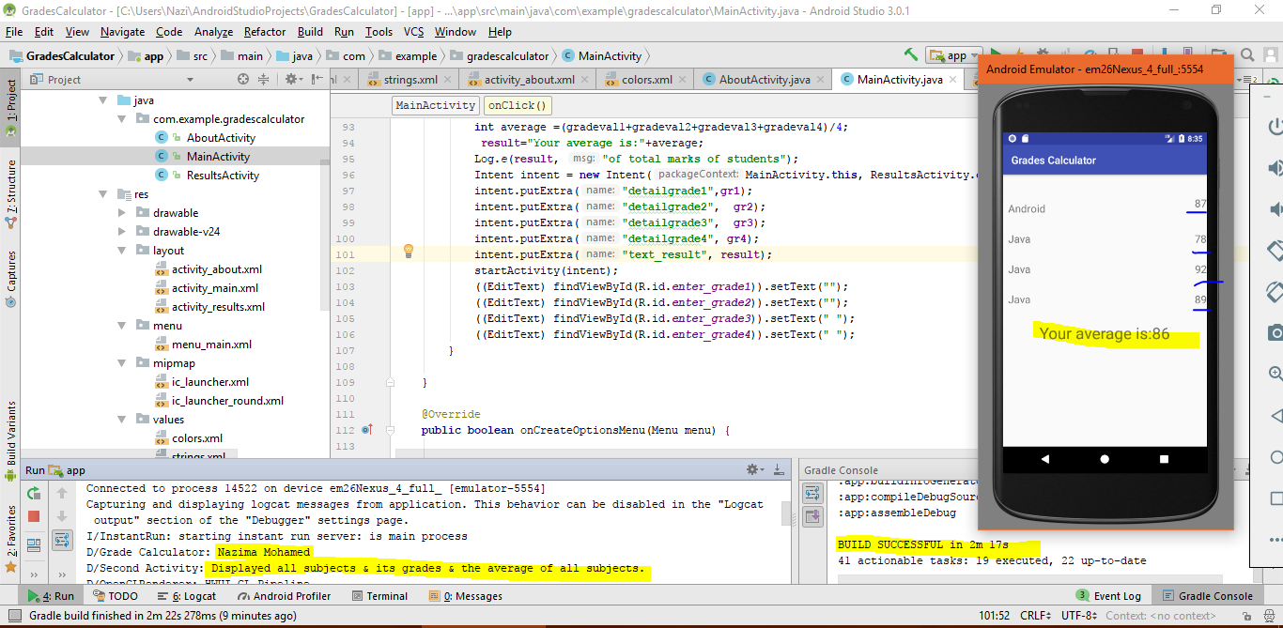

Applied App Compativity Theme while clicking About button in the Options Menu.

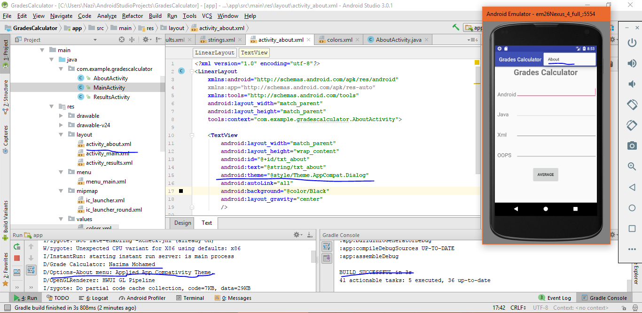

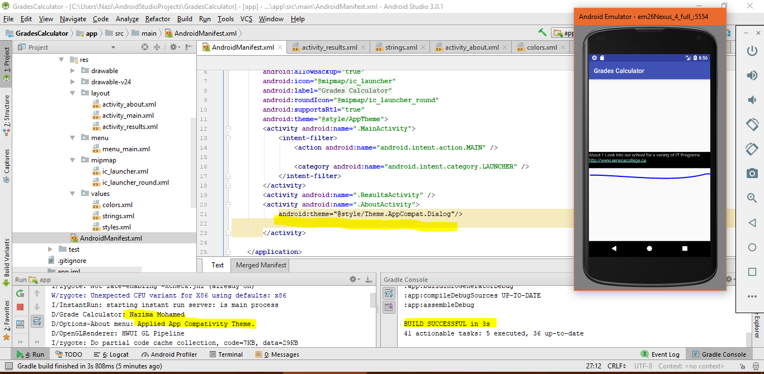

Showed debugging strategy using LogCat.

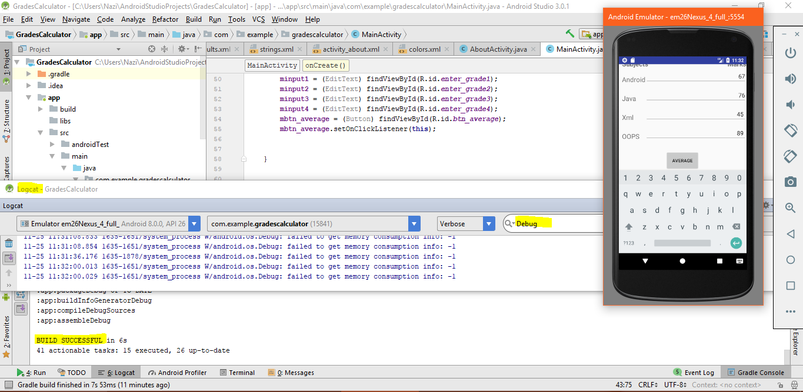

Created AutoComplete TextView to display an array of colleges searching by a String

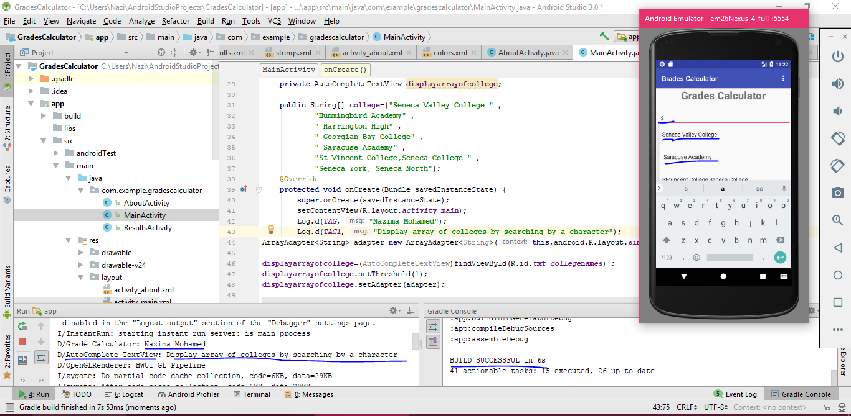

Showed Max, Min button horizontally & assign weight attribute for both as 1 and for the average button assign weight as 3.

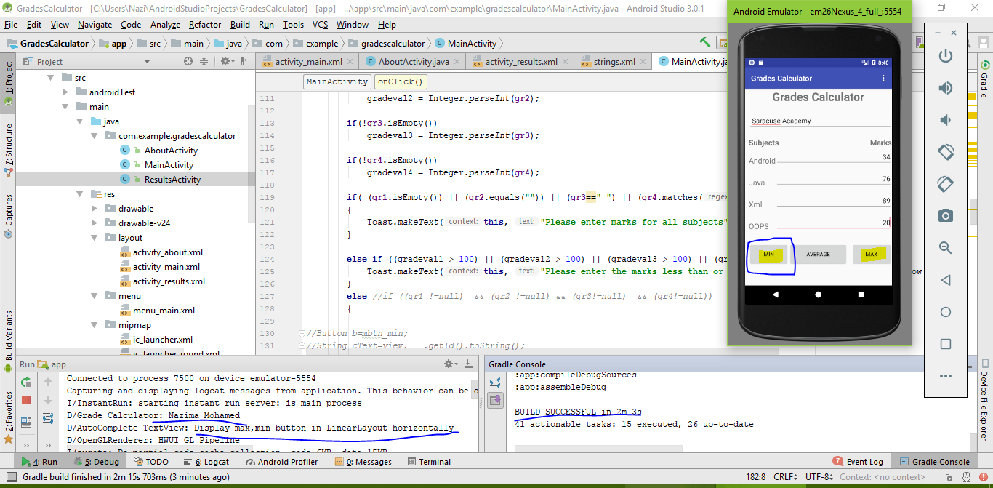

Showed the minimum marks of a student in a specific subject among the 4 subjects. And also showed functionality for Max button as well.

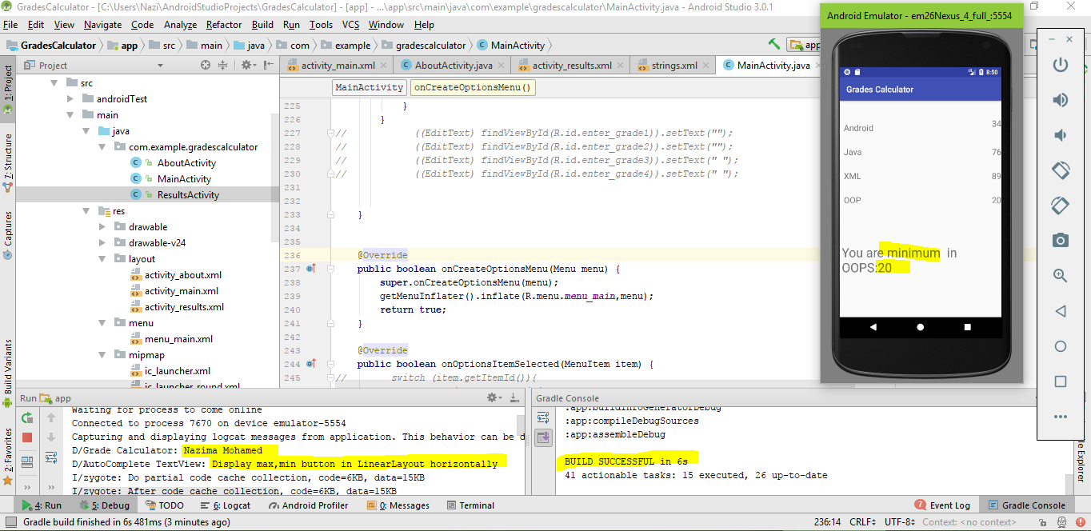

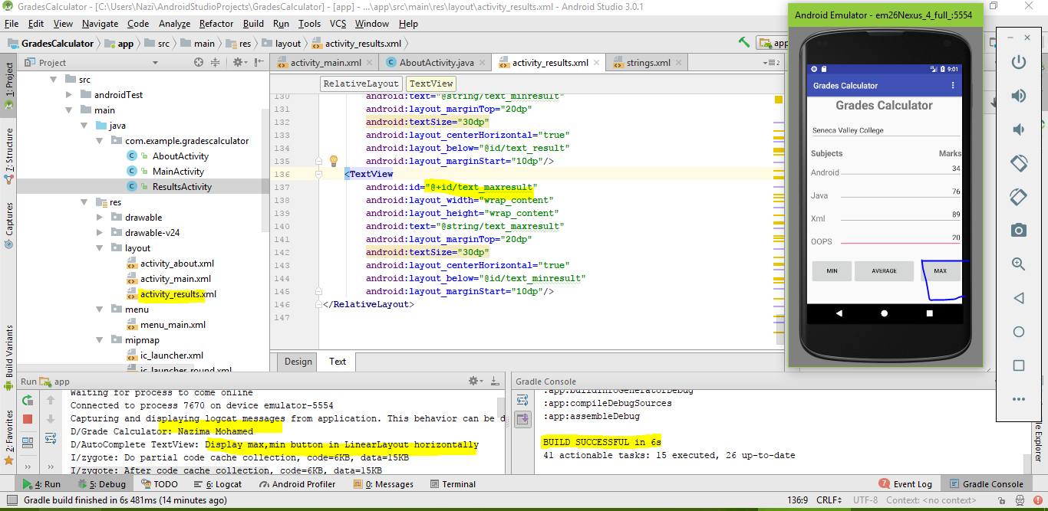

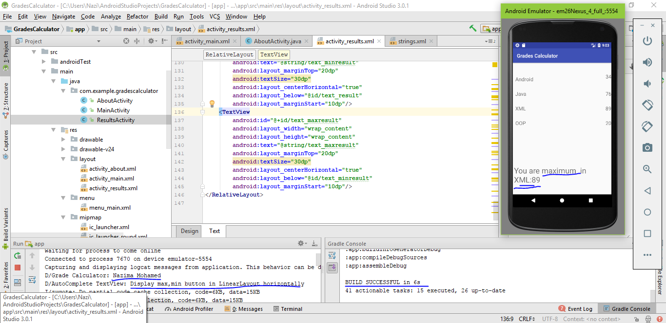

**Displayed max,min options in Action Bar & showed its events**

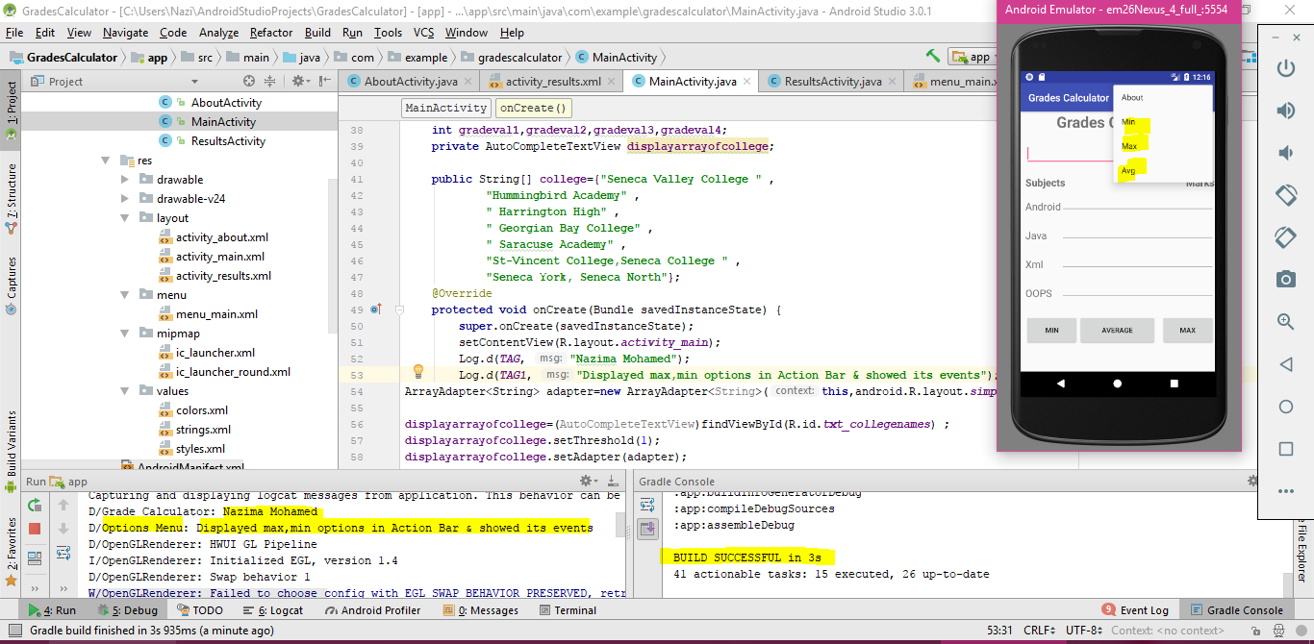

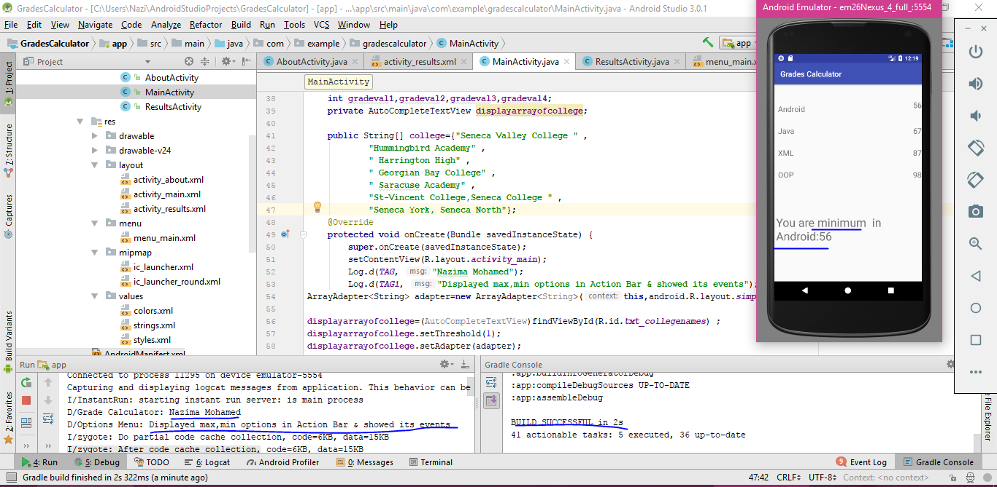

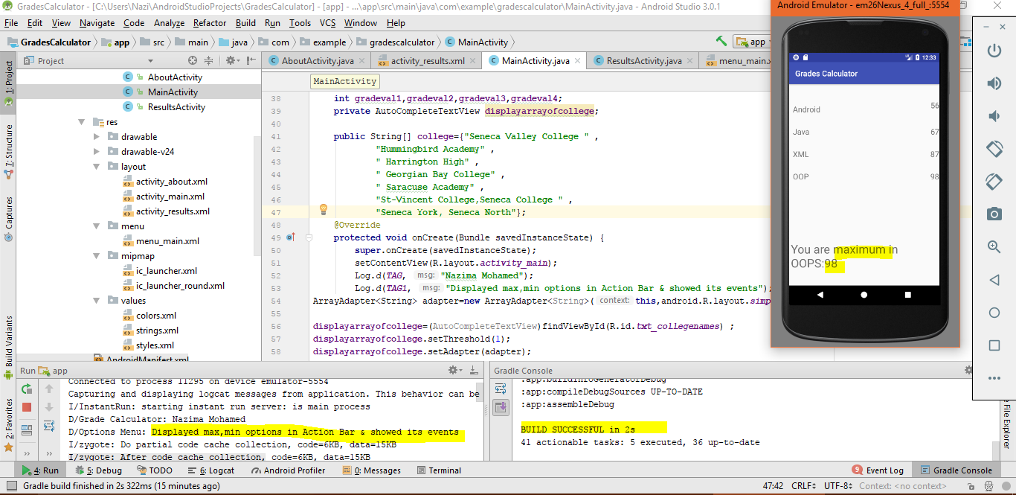

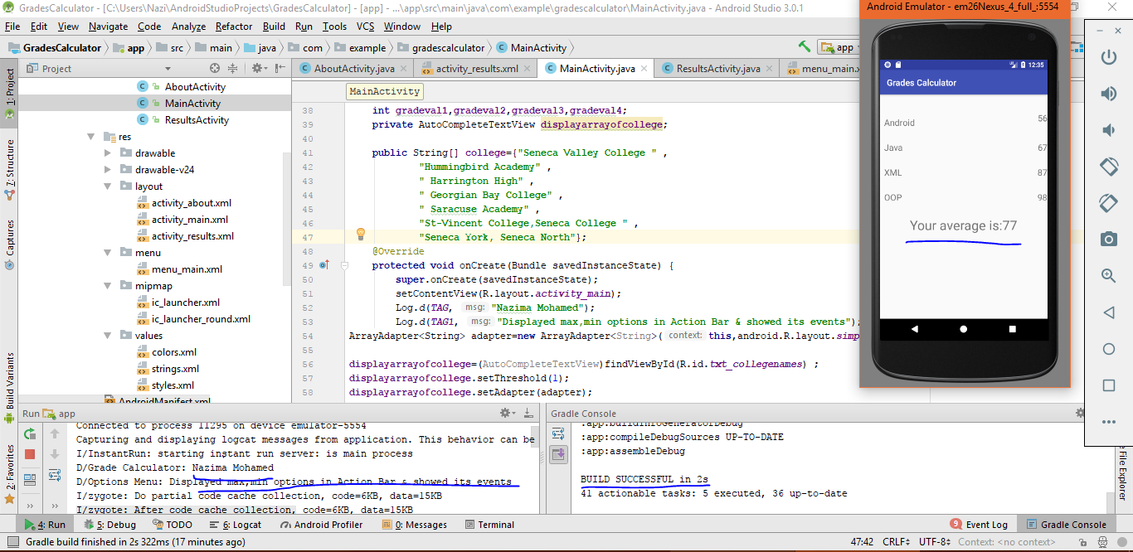

**************************************************************************************************************************************************************************PART-4 (HelloAbout Application with AlertAbout Fragment)

Created menus –AlertAbout & Exit.

Created AlertAboutFragment Java class & created layout-alertabout.xml which contains TextView & OK button to appear in a fragment.

